**Situation Report: No. 001**

South Sudan Cholera Outbreak Situation Report

**Date of onset of outbreak:** 14 April 2022

**Reporting date:** 07 May 2022

**Data Source:** State Ministry of Health & National Reference Laboratory

**EVENT: CHOLERA 31 CASES  1 DEATH CFR - 3.2% GRADE: UNGRADED**

**Highlight:**

* The South Sudan Ministry of Health reported a confirmed case of cholera from Bentiu IDP Camp on 14 April 2022.
* This is the first cholera case to be reported in South Sudan since the devastating cholera outbreak in 2017 affecting more than 28,000 people with 644 deaths.
* The case patient is a 29-months old patient who tested positive by Rapid Diagnostic Test (RDT) on 21st of March 2022 from the Bentiu IDP Camp, Rubkona county.
* On 25th March 2022, *Vibrio cholerae* was isolated from the sample on culture at the National Public Health Laboratory (NPHL) in Juba and was confirmed in the Microbiology Reference Laboratory in Kampala, Uganda.
* Following the national Rapid Response Team (RRT) deployment to Bentiu from 22-29 April 2022, seven additional cholera cases were confirmed by culture during the week ending 30 April 2022.
* Cumulatively, 31 suspected cases have been reported, of which 12 were cholera RDT positive and eight (8) tested culture positive at the National Reference Laboratory in Juba. One of the RDT positive cases died giving 3.2% case fatality ratio (CFR).
* Majority (52%) of the cases are females, while their males counterparts accounts for 48%. The age group between 0-4 years accounted for 45.2%, followed by age group ≥20 years with 22.6%, age group 10-14 years accounted for 16.1%, age group 5-9 years accounts for 9.7%, and age group between 15-19 years accounts for the least with 6.5% of the total 31 cases reported.
* In Bentiu and Rubkona IDP camps, flood surface water is used to bathing and playing. Rubkona county experienced unprecedented floods in 2021 with flood waters persisting up to the end of the current dry season.
* All the cases admitted have been treated and discharged, no case is currently in admission in Bentiu IDP camp treatment center.

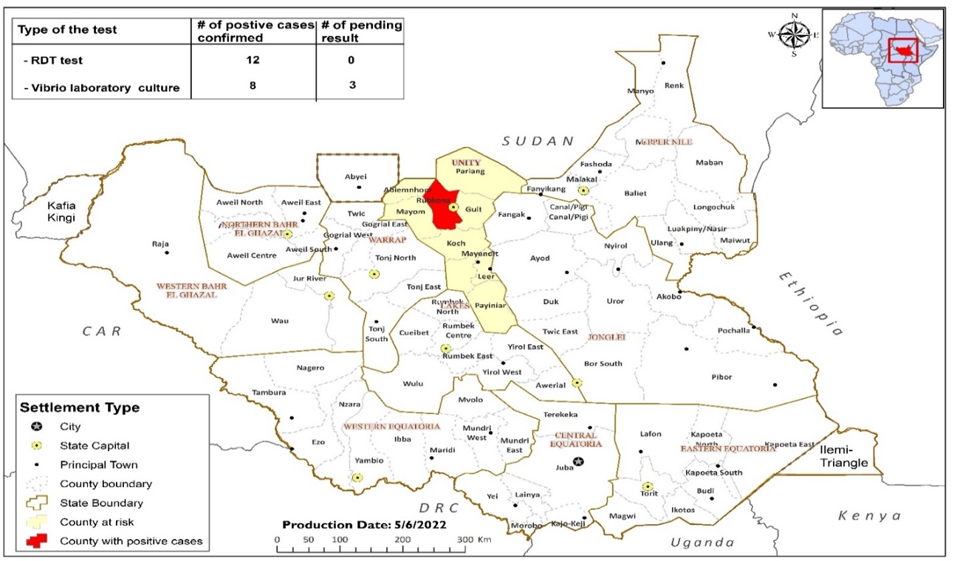

**Figure 1: Geographical Distribution of Cholera Cases by County, South Sudan, 20 March – 29 April, 2022**

**Figure 2: Epicurve of Positive cholera cases in South Sudan, 20 March to 29 April 2022**

Majority (52%) of the cases are females, while their males counterparts accounts for 42%. The age group between 0-4 years accounted for 45.2%, followed by age group ≥20 years with 22.6%, age group 10-14 years accounted for 16.1%, age group 5-9 years accounts for 9.7%, and age group between 15-19 years accounts for the least with 6.5% of the total 31 cases reported.

**Figure 3: Distribution of reported suspected cases by sex and age, Rubkona County, 29 April 2022**

**Figure 3: Epicurve of Positive cholera cases by week in South Sudan, 20 March to 29 April 2022**

Current Response Intervention by thematic areas

**Coordination**

* 1. The Overall coordination of the cholera response is at the State and County levels with technical and operational support from the national level to review trends and progress of implementation of response activities.
  2. The national rapid response team has been activated and deployed to Bentiu from 22 to 29 April 2022 to conduct epidemiological investigations and environmental assessments.
  3. The Ministry of Health activated the PHEOC on 14 April 2022 and issued a media statement declaring a confirmed cholera case in Bentiu.
  4. The Ministry of Health and partners conducted a cholera debriefing meeting on 6 May 2022 and resolved to issue an updated media statement and situation update on cholera.
  5. WHO is supporting the MoH and partners to finalized the national cholera contingency plan to guide resource mobilization, implementation, and monitoring the response to the ongoing outbreak.

1. **Surveillance and Reporting**
   1. Developed and disseminated the outbreak case definition to the Unity State Ministry of Health for onward distribution to 20 health facilities in Bentiu IDP camp and Rubkona Town.
   2. Printed and distributed the surveillance tools including case investigation forms, line list forms to the 20 health facilities in Bentiu IDP camp and Rubkona Town managed by CASS, CORDAID, Concern Worldwide, IRC, World Relief, and IOM.
   3. Suspected cholera cases are being investigated at the sub national level by surveillance officers at county and health facility levels
   4. The National Rapid Response Team conducted mentorship for 20 health workers on cholera case definition to enhance case detection in 20 health facilities in Bentiu IDP camp and Rubkona Town
   5. Active case search is ongoing in the Bentiu IDP camp and Rubkona Town involving Community Health workers. A retrospective review of the health facility records by the National Rapid Response Team in 5 health facilities in Bentiu IDP Camp showed increased in AWD cases (>3000 cases) from January – April 2022.
   6. Surveillance has been heightened in Bentiu IDP camp including provision of mentorship to five health facilities surveillance focal persons by the national rapid response team that were deployed on 22 April 2022 to enable them to identify, or diagnose priority diseases using standard case definition
2. **Laboratory and Testing**
   1. Thirty one (31) samples have been tested since March 20, 2022: 12 samples tested positive on RDTs of which 8 were confirmed by culture in the National Reference Laboratory in Juba.
   2. WHO has prepositioned sixty five (65) Rapid Testing kits contained in 895 cartoons to 20 health facilities in Bentiu IDP camp and Rubkona Town managed by CASS, CORDAID, Concern Worldwide, IRC, World Relief, and IOM.
3. **Risk Communication and Community engagement**
   1. The State Ministry of Health and partners are supporting daily radio messages on cholera awareness and prevention on community stations in the local dialects in Bentiu and Rubkona town.
   2. The Rubkona County Health Department has also embarked on mass awareness in public places through distribution of fliers and community engagement meetings in the affected areas.
4. **Water Sanitation and Hygiene (WASH)**
   1. Forty-six (46) water samples tested of which 18 (39%) were tested positive for total coliforms from the household water drinking sources in the Bentiu IDP Camp and Rubkona Town. While 28 (61%) of the samples tested negative, mostly those samples from the water treatment plants. This thus highlighting contamination of household water storage containers.
   2. Three days capacity building workshop on WASH/IPC for 20 participants from 20 health facilities in Bentiu IDP Camp and Rubkona town managed by CASS, CORDAID, Concern Worldwide, IRC, World Relief, and IOM
   3. There are total of 2,642 functional latrines in Bentiu IDP camp serving a total population of 108,456 people far below the sphere standard of one functional latrine per 20 persons. (e.g.: Sector 1 Target Pop: 21,499 with 280 functional latrines indicating 77 persons/latrine; Sector 2 target Pop: 17,005 with 536 functional latrines indicating 32 persons/latrine; Sector 3 target pop: 24,490 with 810 functional latrines indicating 31 persons/latrine; Sector 4 Target Pop: 17,253 with 208 functional latrines indicating 83 persons/latrine and Sector 5- Target Pop: 28,209 with 808 functional latrines indicating 35 persons/latrine).
5. **Case Management and Infection Prevention and Control (IPC)**
   1. All the 31 cases ( suspected and confirmed cases) have been treated and discharged.
   2. WHO has prepositioned sixty five (65) Rapid Testing kits contained in 895 cartoons to 20 health facilities in Bentiu IDP camp and Rubkona Town managed by CASS, CORDAID, Concern Worldwide, IRC, World Relief, and IOM.
   3. Hand hygiene practices have been reinforced at health facilities and communities in the affected areas by IOM and other partners in Bentiu IDP camp and Rubkona Town
   4. MSF established 55 bed treatment centre in Bentiu IDP camp and currently supporting cholera case management.
   5. Cholera treatment protocols are available in the 20 health facilities managed by CASS, CORDAID, Concern Worldwide, IRC, World Relief, MSF, and IOM; Case management training is planned.
6. **Point of Entry (POE)**
   1. Mapped all official and unofficial POEs in seven counties (Juba, Magwi, Rubkona, Kapoeta East, Ikotos and Kajo Keji) to preposition supplies and materials.
   2. Due to inadequate cholera control measures at the porous borders, there is a high risk of cases being exported beyond Rubkona to neighboring counties including Juba hosting majority of the country’s population.
   3. Flooding and insecurity in counties bordering Rubkona county pose a high risk of continuous cholera outbreak as new IDPs with no protection against the disease continue to arrive in the IDP camps in Bentiu and Rubkona town
7. **Oral Cholera Vaccines**
   1. Two rounds of Oral Cholera Vaccines (OCV) have been conducted in Rubkona county where the cases are being reported. Between 25-31 January 2022, a cumulative total of 173,170 (85%) out of the target population of 202,627 individuals were reached with the first dose vaccine in Bentiu IDP camp, Site ABCDE, Bentiu and Rubkona towns. The second round OCV campaign took place between 14-20 March 2022, a total of 175 044 (86%) out of the target population of 202,627 individuals were vaccinated in the above locations.
   2. WHO is supporting the Unity State Ministry of Health to conduct the post campaign evaluation to validate the administrative coverage of 86% reported from Rubkona County.
   3. The State Ministry of Health, WHO, IOM, Unicef, and partners have planned to vaccinate the remaining hard to reach areas in Rubkona County (Dhorbor-buaw-Wunbut, Ngop, Wathjak,Tong, Jezira, Kaljak, Pahkur, Ding, Budang, Roriak, oilfield, Payingai and the army Barracks) with 33,000 people.
   4. The Ministry of Health and Partners have planned to conduct risk assessments to identify high risk areas that are not listed as cholera hotspots to be prioritized for OCV pre-emptive campaigns. Working with the health cluster, the following locations with high risk populations have been identified for pre-emptive campaigns: Leer, Mayendit, Panyijiar, Fangak, and Gogrial West.
   5. The Ministry of Health with support from WHO has planned to conduct OCV campaigns in the remaining category A prioritized cholera hotspot counties (Juba, Awerial, Yirol East, Panyijiar, Kapoeta North, and Duk)

**Situation Context**

South Sudan remains at risk for potential cholera outbreaks due to limited access to safe water and poor sanitation, the presence of displaced populations, floods, and repeated cycles of sub-national violence. Cholera outbreaks in South Sudan usually occur during the rainy season. Since 1980 to 2017, South Sudan has experienced ten (10) major cholera outbreaks that have varied in magnitude from 17 to 48,035 cases, with case fatality rates (CFR) ranging between 0.13% and 2.9%. Generally, most cases occurred in major urban centers like Juba, along water bodies like the River Nile, in internally displaced camps, in cattle camps, flood affected locations, and other locations with inadequate access to safe water and improved sanitation facilities.

On 14 April 2022, South Sudan reported its first confirmed of cholera since the last outbreak in five years. The main risk factors include inadequate access to clean and safe water, inadequate sanitation facilities, significant high risk due to high level of contaminated surface water following flooding including limited flushing and disinfection of the wells and boreholes.

The National Rapid Response Team (RRT) has been activated to support the affected county with leadership from Office of the Director General of Preventive Health Services of the Ministry of Health support from partners and central government.

There is an increase in acute watery diarrhoea cases since the beginning of 2022, average of 890 cases per week in Bentiu IDP and town. Cumulatively, from January to April, 2022, a total of 3,704 acute watery diarrhoea cases reported across five health facilities in the IDP camp.

The risk of transmission remains very high largely due to high population movements into the affected area as the county hosts approximately 300,000 people, in a limited space associated with flooding, and poor sanitation.

**CHALLENGES**

* While the National Public Health Laboratory is able to perform culture testing of samples, the laboratory lacks reagents for cholera serotyping and sensitivity testing.
* Inadequate sample collection from suspect cases for onsite (health facility level) RDT testing and sample referral for culturing.
* Inadequate access to improved sanitation facilities that is below the sphere standards in all the sectors of Bentiu IDP camp and Rubkona town IDPs.
* Environmental assessment demonstrated contamination of water storage containers at household level and along the water reticulation network in Bentiu IDP camp.
* Sub-optimal community engagement and risk communication in affected and high risk populations on cholera prevention and control.
* Limited first line weekly supportive supervision for surveillance at health facility for passive surveillance and mentorship for clinic staff remains a challenge.
* Healthcare workers in the area have limited knowledge on standard case definitions for cholera due to attrition of trained staffs.
* Influx of unvaccinated IDPs from neighboring counties into Bentiu where OCV campaigns have been conducted.
* Insecurity with associated frequent displacement
* Upcoming flooding season to negatively impact case detection, reporting, investigation, testing, and management across hotspot location.

**NEXT STEPS BASED ON CONTEXT ANALYSIS**

* Update and issue a press statement and a situation update on the cholera situation in South Sudan.
* As per the South Sudan emergency Preparedness and Response Plan, grade the outbreak, designate an incident manager and team to coordinate response activities .
* Support the state to activate a multisectoral platform to coordinate the response in Bentiu and strengthen preparedness and response readiness in the other high risk counties in Unity state.
* Finalize the cholera response plan for Unity state and engage the other states to update their respective cholera contingency plans and overall cholera response readiness.
* Mobilize resources to facilitate the implementation of cholera contingency and response plans in affected and high risk states.
* Procure laboratory reagents and supplies to facility serotyping and sensitivity testing in the NPHL.
* Print and disseminate all required surveillance tools including case investigation forms, laboratory submission forms, and case definitions.
* Continuous mentorship for surveillance officers and health facilities focal persons on priority diseases case definitions – especially cholera to improve case detection, reporting and investigation.
* Improve risk communication and community engagement through mass awareness in public places and distribution of fliers and community engagement meetings in the affected areas.
* Investigate and respond to all cholera alerts reported from communities and health facility through active case search.
* Strengthen routine IDSR surveillance, including trend analyses for routine diseases like non-bloody diarrhoea.
* As a sustainable measure, initiate community led total sanitation (CLTS) activities which include construction of hand pumps and latrines in communities – by third quarter of 2022.
* Implement OCV campaigns in the remaining cholera hotspot locations, especially, Juba city and others that are flood affected or flood prone.

**SPECIFIC NEEDS**

* Cholera testing antisera and supplies for sensitivity testing.
* Training of frontline health workers and community health workers on cholera surveillance, case management, infection prevention and control, and community engagement for cholera control.
* Need to establish and address integrated surveillance and response gaps.
* Coordination of protection actors. Awareness on Gender Based violence and referral mechanisms and security related information.

**CONCLUSION**

The Ministry of Health has confirmed an outbreak of cholera in Rubkona county with all the cases reported in vulnerable IDP populations. The gaps in surveillance, case management, community engagement and WASH need to be urgently addressed to prevent a widespread outbreak and avert needless deaths. It is also critical that countrywide preparedness and response readiness are enhanced in the other high risk counties and states to prevent or mitigate the impact of cholera outside Rubkona county.

**Acknowledgements**

The South Sudan Ministry of Health appreciates the partnership and support from:

* Line ministries (Ministry of Water Resources and Irrigation)
* UN agencies (WHO, Unicef, IOM, WFP, OCHA)
* Medecins Sans Frontiers – Holland
* Humanitarian cluster partners (Health, WASH, Camp Coordination and Camp Management)
* Development partners
* Donors

**CONTACT INFORMATION**

Incident Lead: **Dr. John Rumunu**  [jrumunu@yahoo.com](mailto:%20%20%20%20jrumunu@yahoo.com)

EPR Director: **Dr. Joseph Lasu** [josh2013.lasu@gmail.com](mailto:josh2013.lasu@gmail.com)

***PHEOC Hotline: 6666***